**ASSIGNMENT 2 FRONT SHEET**

|  |  |  |  |  |  |
| --- | --- | --- | --- | --- | --- |
| **Qualification** | **BTEC Level 5 HND Diploma in Computing** | | | | |
| **Unit number and title** | Unit 2: Networking Infrastructure | | | | |
| **Submission date** |  | **Date Received 1st submission** | |  | |
| **Re-submission Date** |  | **Date Received 2nd submission** | |  | |
| **Student Name** | Bùi Hương Linh | **Student ID** | | GBH200662 | |
| **Class** | GCH1002 | **Assessor name** | | Michael Omar | |
| **Student declaration**  I certify that the assignment submission is entirely my own work and I fully understand the consequences of plagiarism. I understand that making a false declaration is a form of malpractice. | | | | | |
|  |  | | **Student’s signature** | | https://lh3.googleusercontent.com/vIDf2DoZD7wUyGqC2jj-U1Z4SqqtCzr7e85DM1Zu9ymLibTvLTHOMQYynmE1uw4-uIrvfi5UIPEI4NXe5nJT7XOQzYLOTUxRUynnzDSS8_B2B1C0rcS9BWwzB9k9el7KpnycuzQqRf3Bfc4Kgw |

**Grading grid**

|  |  |  |  |  |  |  |  |
| --- | --- | --- | --- | --- | --- | --- | --- |
| P5 | P6 | P7 | P8 | M3 | M4 | D2 | D3 |
|  |  |  |  |  |  |  |  |

|  |  |  |
| --- | --- | --- |
| **❒Summative Feedback: ❒Resubmission Feedback:** | | |
| **Grade:** | **Assessor Signature:** | **Date:** |
| **Lecturer Signature:** | | |

Contents

Introduction: 4

Task 1 - Provide a logical/physical design of the networked system with a clear explanation and addressing table (P5) 4

1. Explain the difference between logical and physical design. (Alex Heath, 2021) 4

2. Discuss and explain the user requirements for general network design. 4

Task 2: Evaluate the design to meet the requirements (P6) 7

3. A test plan for the design above without specific results. 7

4. For this design network to work effectively, provide any advice or solutions to the users? 8

Task 3 - Implement a networked system based on a prepared design (P7) 8

5. A screenshot of this realization as proof of the network implementation designed above 8

6. Diagram of the overall network realization, which contains all of the network devices active based on the original user requirements. 10

Task 4 - Document and analyze test results against expected results (P8) 12

7. Based on the network realization diagram above, write down the above implementation process into the logbook, so that later on when you need to expand the network or have a network problem, you can easily handle it. 12

8. Test results, based on the test plan done above. 12

Bibliography 25

# Introduction:

After being employed as a network engineer by Nguyen Networking Limited, a firm that creates high-tech networking solutions, I finished my first report. My next task will be to study the organizational requirements that I provided before. In this report, I plan to build and create a network project that I am very much looking forward to.

# Task 1 - Provide a logical/physical design of the networked system with a clear explanation and addressing table (P5)

1. Explain the difference between logical and physical design. (Alex Heath, 2021)

* Logical design:
* The logical design of a system pertains to an abstract representation of the data flows, inputs and outputs of the system. This is often conducted via modeling, using an over-abstract model of the actuall system.
* Physical design:
* The physical design is a graphical representation of a system showing the system's internal and external entities, and the flows of data into and out of these entities.

1. Discuss and explain the user requirements for general network design.

* A logical design of the network based on the specific requirements of the user.

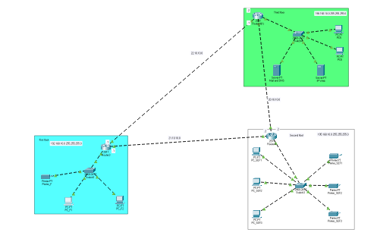

Image 1: Logical design

* In the logical design consists of three main network floors each with one router.( assumption)

+ The first floor is the staff floor . This floor consists of 2 computers connected together.

+ The second floor is the student lab floor. This floor consists of 3 computers connected together.

+ The third floor is the student lab floor. This floor consists of 2 computers connected together.

+ These rooms are all connected to the network and connected to the server, the machines are all linked together, stable network connection.

* The physical design of this network is based on the specific requirements of the user.

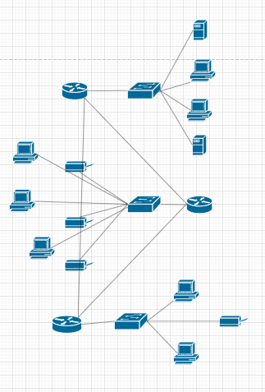

Image 2: Physical design

* In physical design, the devices are divided into floors. The design is completely linked together through wires.(assumption)
* For floor 1 I use switch 24 ports because this floor contains 2 computers and 1 printer.
* For floor 2 I use switch 24 ports because this floor contains 3 computers and 3 printers.
* For floor 3 use switch 24 ports because this floor contains 2 computer and 2 servers.
* The address table of the network devices used in your design above.

Addressing table 1 floor 192.168.10.0

|  |  |
| --- | --- |
| Device | Address |
| Default gateway first floor | 192.168.10.1/24 |
| PC_F1 | 192.168.10.3/24 |
| PC_F2 | 192.168.10.2/24 |
| Printer_F | 192.168.10.4/24 |

Addressing table 2 floor 195.168.10.0

|  |  |
| --- | --- |
| Decive | Address |
| Default gateway second floor | 195.168.10.1/24 |
| PC_SEF1 | 195.168.10.2/24 |
| PC_SEF2 | 195.168.10.7/24 |
| PC_SEF3 | 195.168.10.4/24 |
| Printer_SEF1 | 195.168.10.3/24 |
| Printer_SEF2 | 195.168.10.5/24 |
| Printer_SEF3 | 195.168.10.6/24 |

Addressing table 3 floor 198.168.10.0

|  |  |
| --- | --- |
| Decive | Address |
| Default gateway third floor | 198.168.10.1/24 |
| PC5 | 198.168.10.3/24 |
| PC6 | 198.168.10.4/24 |
| IP Web | 198.168.10.2/24 |
| Mail and DNS | 198.168.10.5/24 |

# Task 2: Evaluate the design to meet the requirements (P6)

1. A test plan for the design above without specific results.

* Evaluation of network design based on user requirements.
* The deployed network system has been effectively stratified to meet 3 basic device levels.
* The routers are fully connected to each other, and each floor corresponds to a router.
* Network flexibility but the complexity is not high.
* Clarity of network topology for logical and physical design
* Pros:

+ The networked system is divided clearly into three different floors: third floor, first floor, and second floor.

+ The network layout has been effectively indicated.

+ Clear design, easy to repair and improve in the future.

+ Can connected with all computer of all floor.

* Cons:

+ No security.

+ Design simple, not enough with requirements.

+ Design is not creative.

1. For this design network to work effectively, provide any advice or solutions to the users?

* We have the option of upgrading the 24-port switch to a 48-port switch. More cables and space are saved with the 48-port switch. Despite the fact that the 48-port switch is more expensive than the 24-port switch, it is simple to regulate all computer cables. It also makes network maintenance and repair easier for us.

# Task 3 - Implement a networked system based on a prepared design (P7)

1. A screenshot of this realization as proof of the network implementation designed above

* Ping:
* Checking the connectivity between third floor with second floor

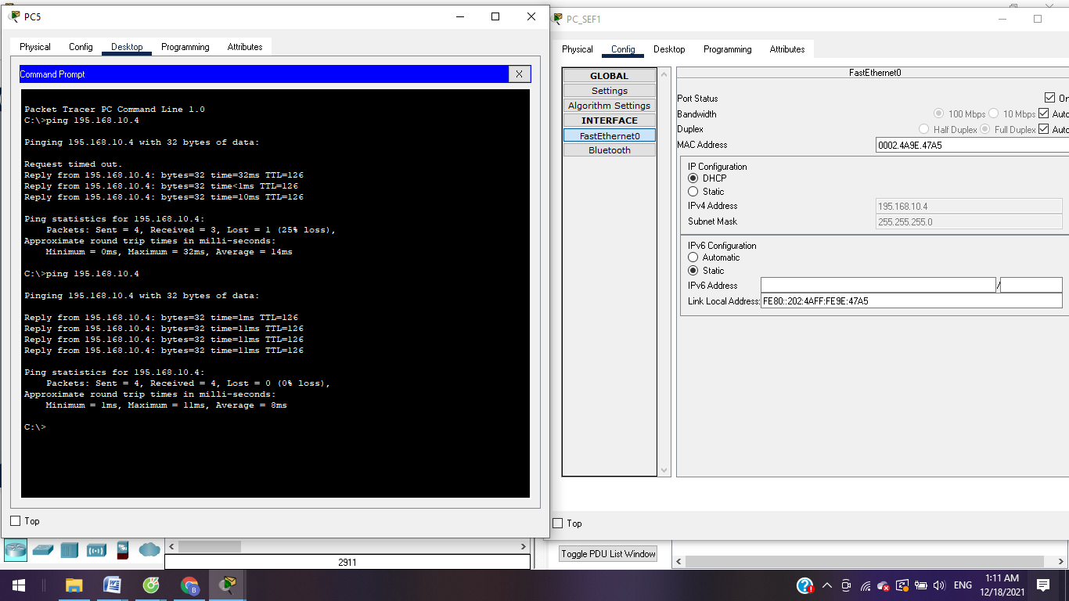

Image 3: Ping testing

198.168.10.4 ping to 195.168.10.4 success

* Checking the connectivity between first floor with third floor

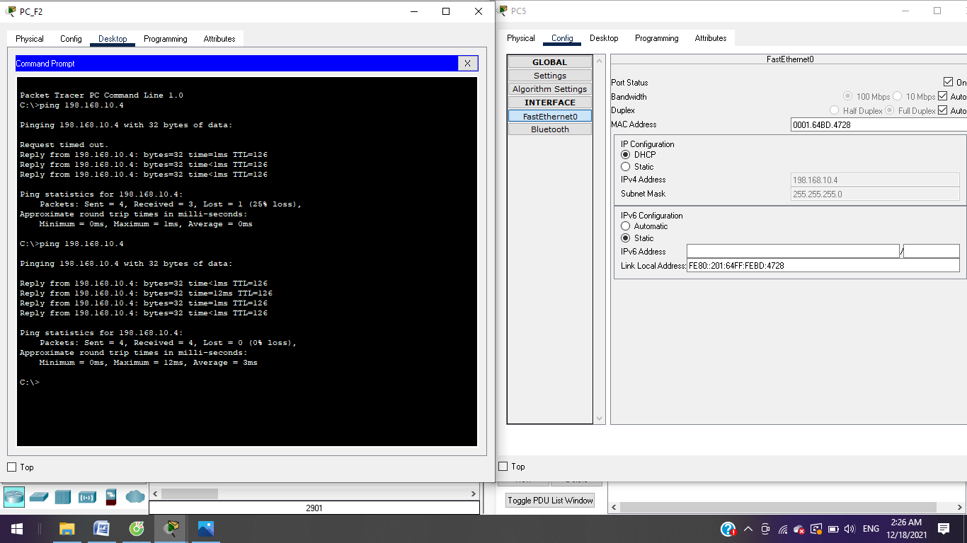

Image 4: Ping testing

192.168.10.2 ping to 198.168.10.4 success

* Checking the connectivity between first floor with second floor

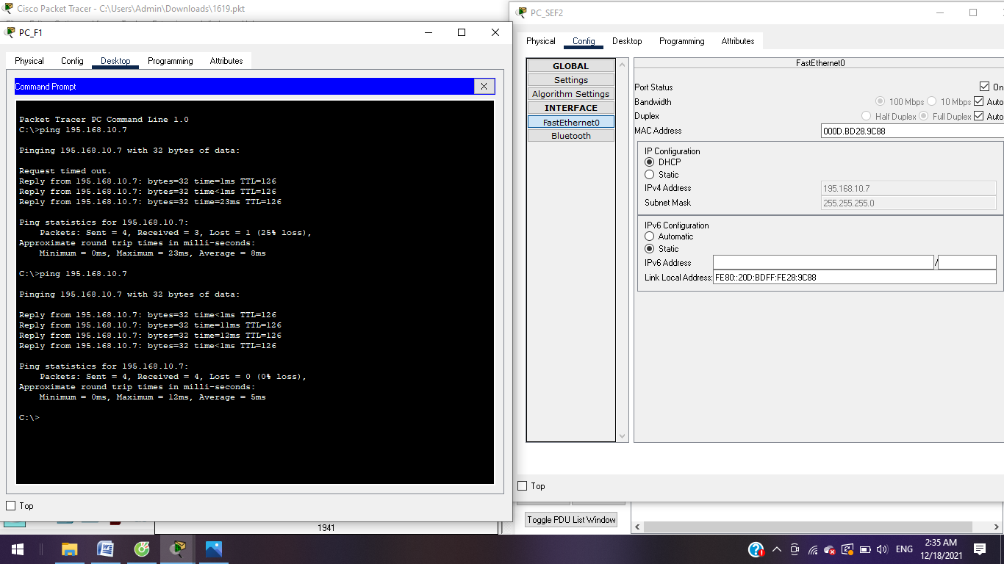

Image 5: Ping testing

192.168.10.4 ping to 195.168.10.7 success

1. Diagram of the overall network realization, which contains all of the network devices active based on the original user requirements.



Although the diagram is very simple, it works very well on all 3 floors. (assuming according to the diagram)

+ 1st floor includes 2 computer and 1 printer.

+ Second floor with 3 computers and 3 printer.

+ Third floor with 2 computer and 2 server.

+ Routers are connected to each other and each floor corresponds to 1 router.

# Task 4 - Document and analyze test results against expected results (P8)

1. Based on the network realization diagram above, write down the above implementation process into the logbook, so that later on when you need to expand the network or have a network problem, you can easily handle it.

* Ping test connecting table:

|  |  |  |  |
| --- | --- | --- | --- |
| Sender | Receiver | Expected result | Real result |
| PC_F1 | Printer­_F | Successfully | Pass |
| PC_SEF2 | Router 4 | Successfully | Pass |
| Router 4(1) | PC5 | Successfully | Pass |
| PC_SEF3 | Printer_SEF3 | Successfully | Pass |
| Router3 | PC_F2 | Successfully | Pass |

* Example:

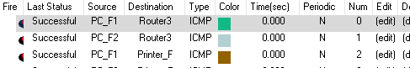

1. Test results, based on the test plan done above.

* Designing the networking system of floor 1

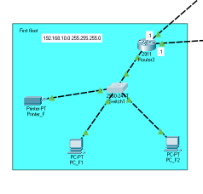

* Configure IP address for Router 3

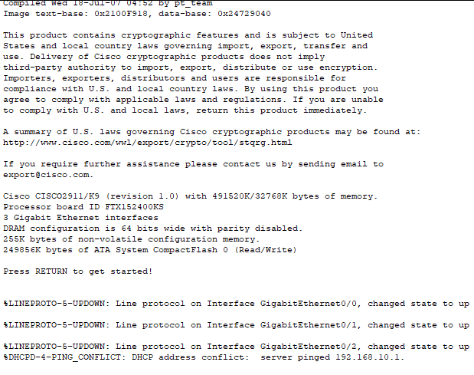

* Interface of PC and Printer in floor 1

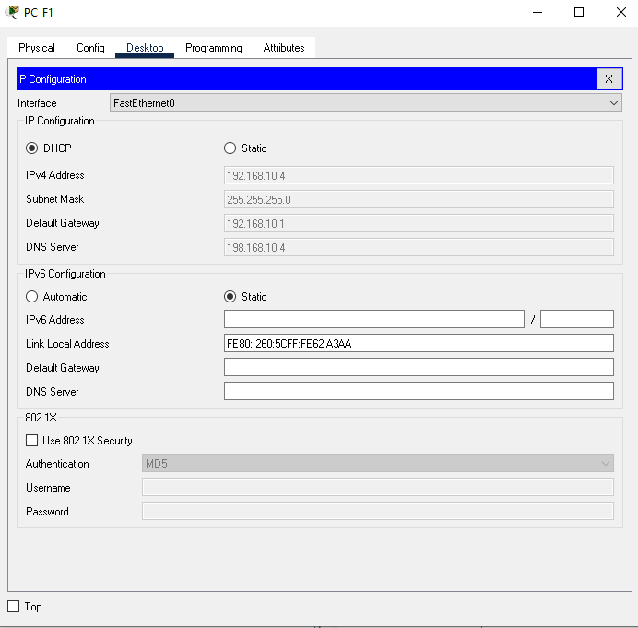

Image 6: Interface of PC_F1

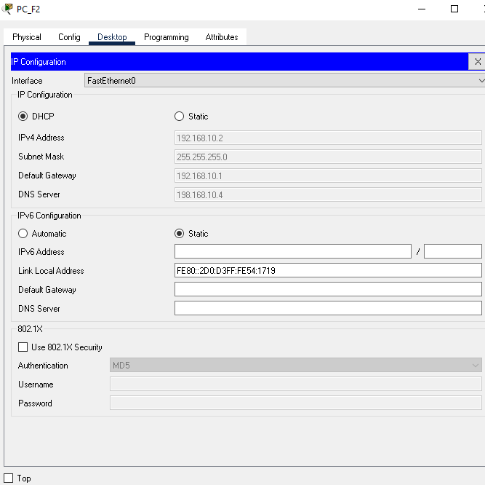

Image 7: Interface of PC_F2

* Designing the networking system of floor 2

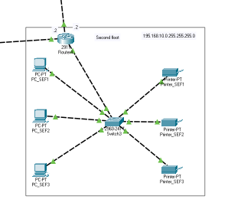

* Configure IP address for Router 4

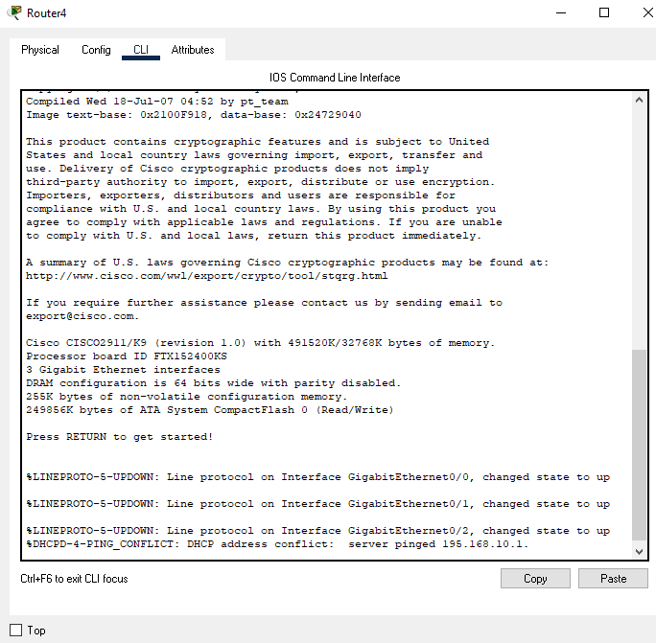

* Interface of PC and Printer in floor 2

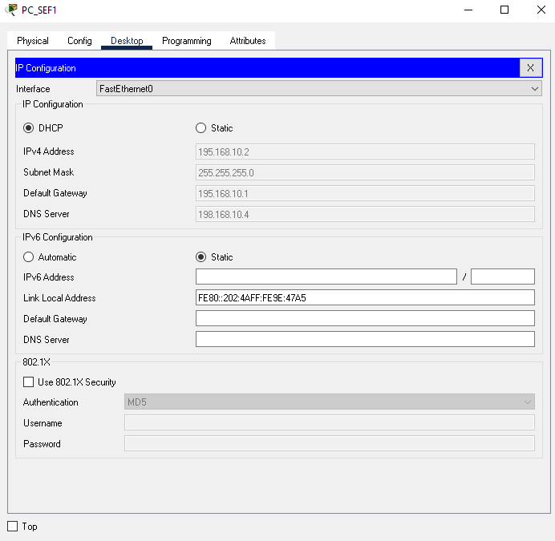

Image 8: Interface of PC_SEF1

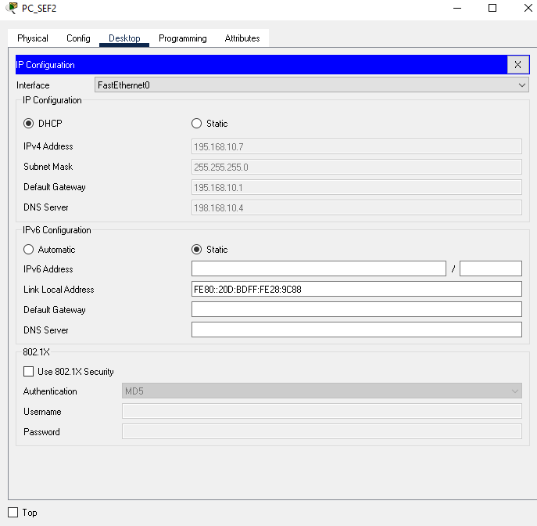

Image 9: Interface of PC_SEF2

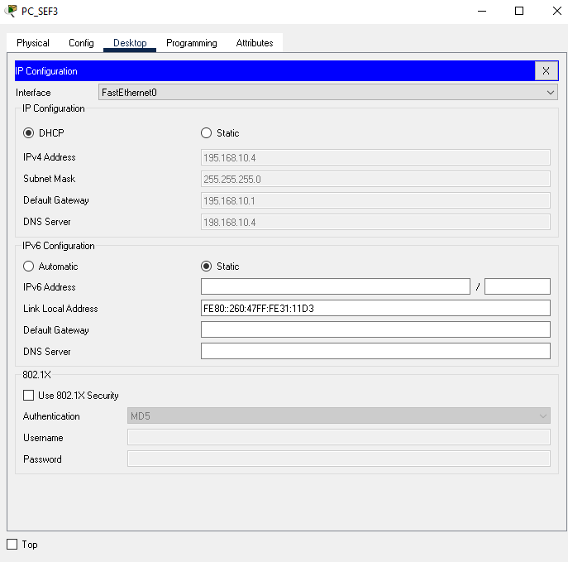

Image 10: Interface of PC_SEF3

* Designing the networking system of floor 3

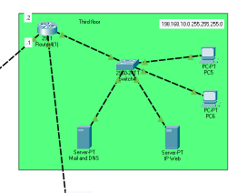

* Configure IP address for Router 4(1)

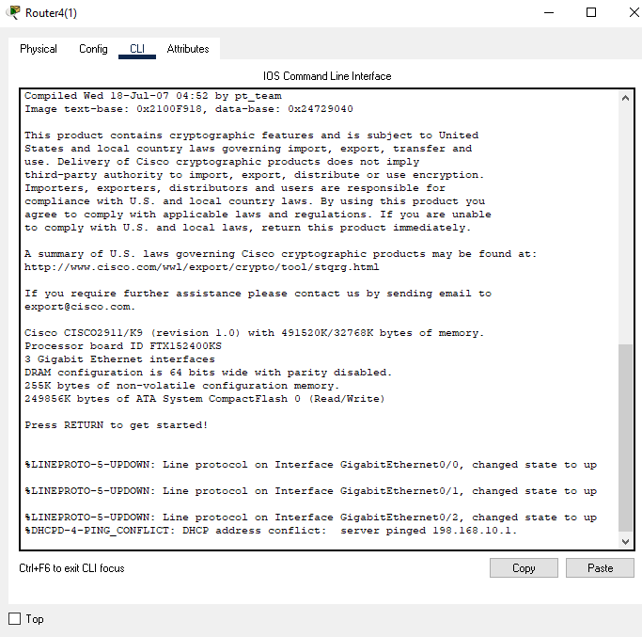

* Interface of PC, Mail and DNS, IP Web in floor 3

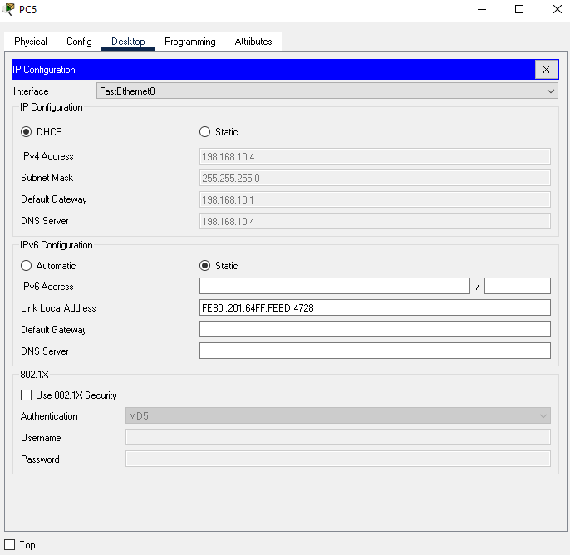

Image 11: Interface of PC5

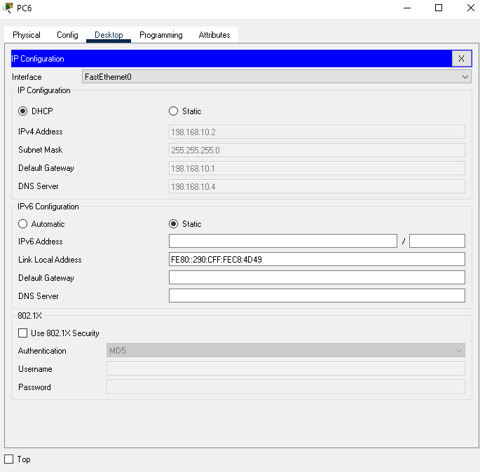

Image 12: Interface of PC6

Conclution

This exercise taught me a lot about network infrastructure and provided me with a wide understanding of the network. I've learnt about the advantages and disadvantages of many types of networks; network, communication, and bandwidth structures; the principles of the network and server types. I created a design networked system. So, based on what I've learnt in this course, I'm going to work on myself and attempt to become a good network engineer.

# Bibliography

Heath, A. (2021, December 16). Retrieved from easierwithpractice.com: https://easierwithpractice.com/what-is-the-difference-between-physical-design-and-logical-design/